]
Marketing Opportunities for Your Business
Eat Exmoor: the story so far….
Eat Exmoor was launched in 2018 to promote Exmoor’s fantastic range of local food and drink; the landscape that yields it, the producers that make it and the creative and hospitable workforce that cook, market, sell and serve it.
Visit Exmoor, working together with Exmoor National Park Authority, undertook a number of projects designed to shine a spotlight on the delicious produce available in the Greater Exmoor area, including a 32-page full colour guide and new website section, a Food & Drink Trade Show, dining events and focussed PR and social media promotions highlighting foodie events and experiences.
To end a hugely successful year, the Eat Exmoor project was ‘Highly Commended’ in the prestigious British Guild of Travel Writers National Tourism Awards, beating off stiff competition to finish amongst the Top 3 projects to be nominated nationally.

What’s next…..
Firstly, we will be producing a refreshed edition of the 32-page full colour Eat Exmoor Guide (advertising rates and information below). Our website will be featuring reviews and tips and hints on where to eat and drink from our visitors. We will be working with retailers and looking at how we can best promote our local produce under the Exmoor brand. And we will be continuing to highlight, promote and share all the great foodie events and experiences, farmers markets and launches that occur in and around Exmoor. If you’d like to be part of this read on…………
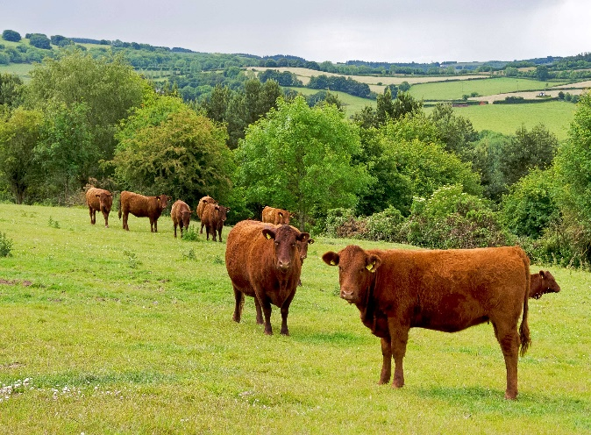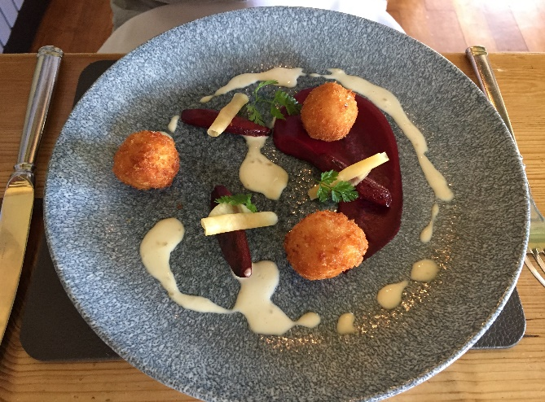

Your Opportunity to be Involved…
Advertising Rates for refreshed guide (ready for March 2019):
A5 Full Colour Guide  10,000 Copies | Visit Exmoor Members | Non - Members
Food & Drink Listing (name/website/phone number) | Free | £50
1/4 page Advert | £50 | £100
1/2 page Advert | £100 | £150
Full Page Advert | £200 | £250
Inside Front Cover | £300 | £350
Inside Back Cover | £250 | £300
Back Cover | £350 | £400

No VAT charged. Deadline 14 December 2018.
New artwork needs to be provided in digital format and can be designed for £20. There will be 10,000 free copies distributed throughout Greater Exmoor from March 2019.

Non – Members can join Visit Exmoor (with all the benefits this entails, from £60 - £290) and then take advantage of members rates for this, and other, upcoming publications.
Membership Benefits
Contact Jennette Baxter: marketing@visit-exmoor.co.uk 07956 829633

Interested?
Please contact Jennette Baxter marketing@visit-exmoor.co.uk with your requirements. An invoice will be sent to you and your space will be confirmed on payment. Deadline 14 December 2018.

